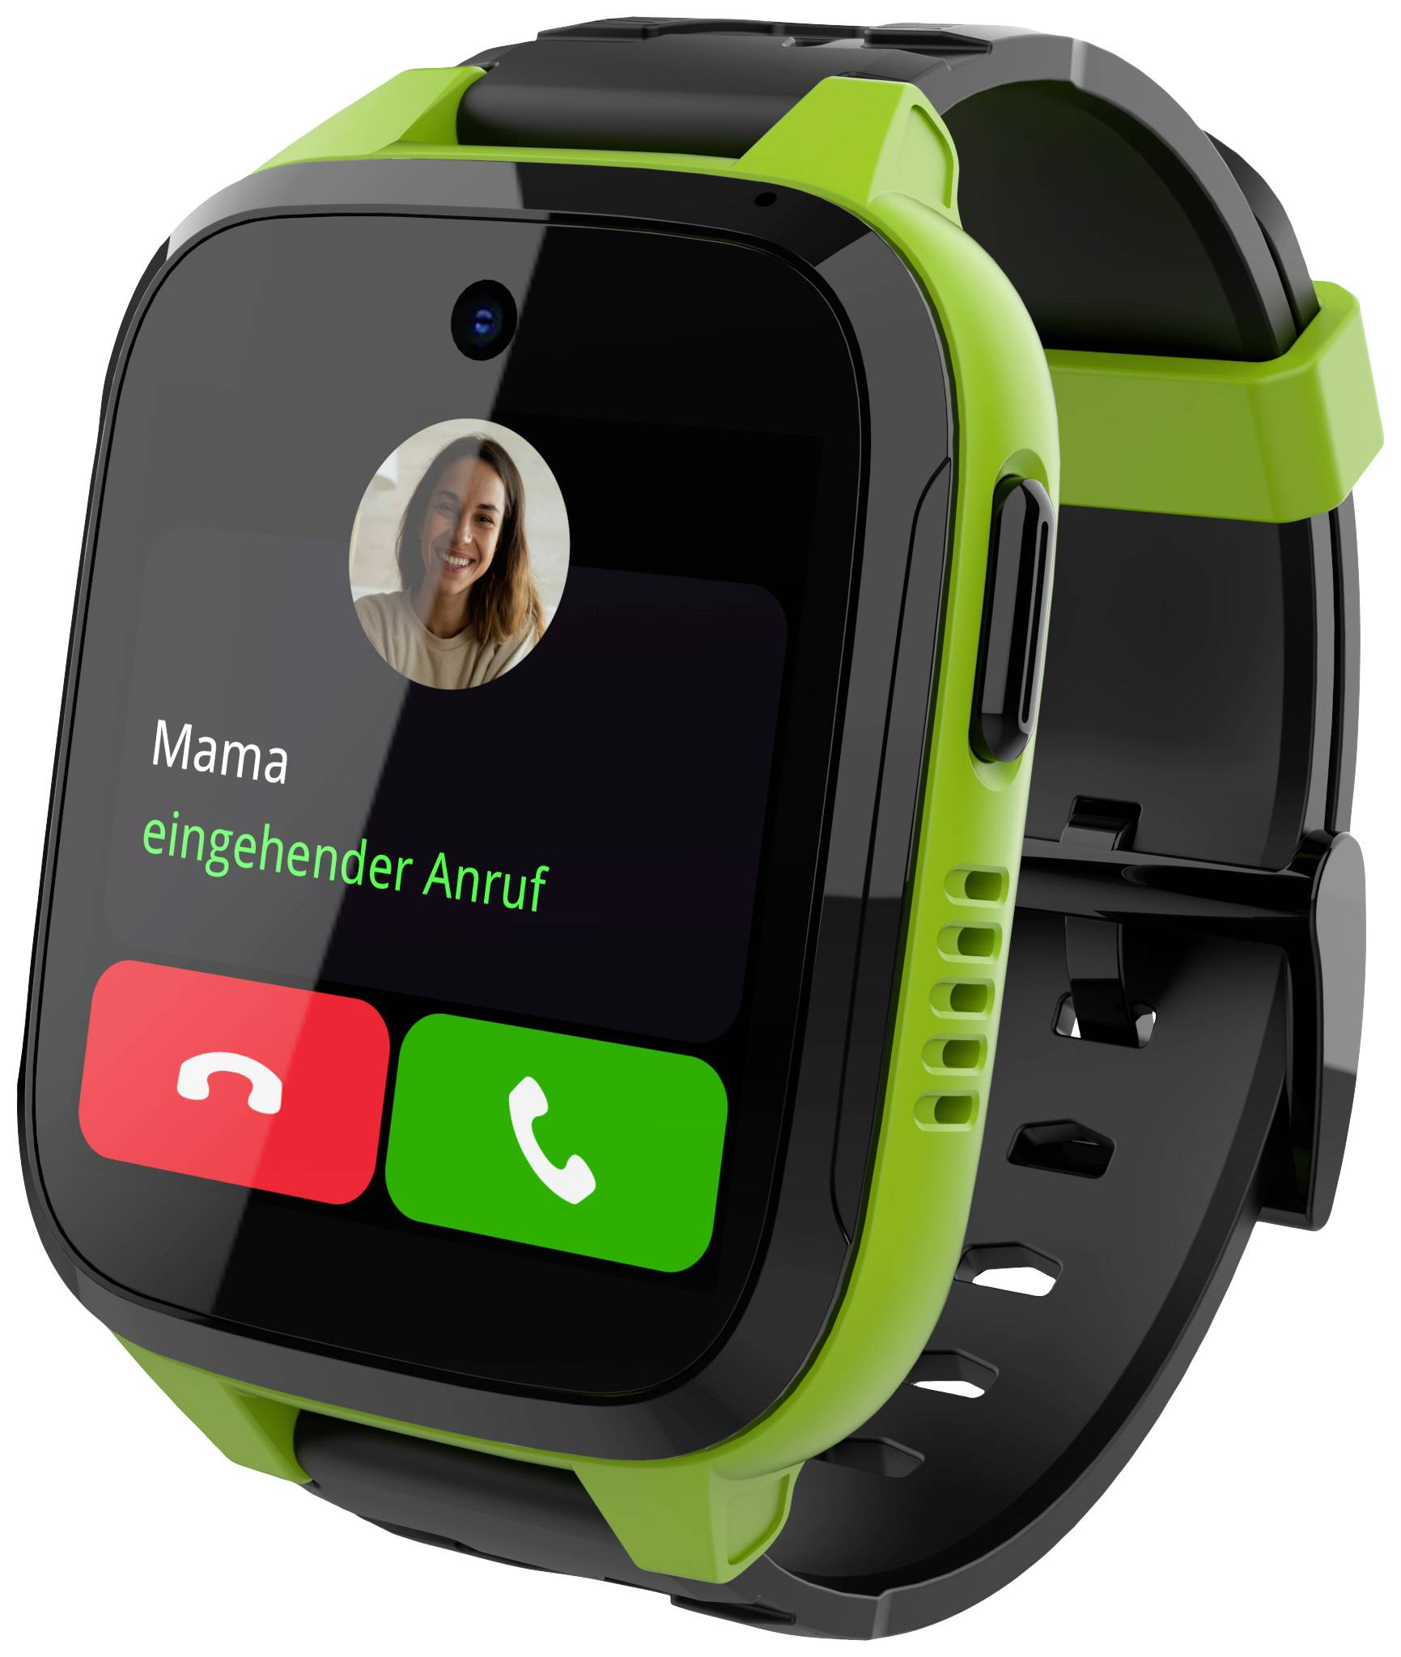**Xplora**

Description: **Xplora** is a leading brand specializing in **smartwatches for kids**, designed to provide a **safe and connected experience** without exposing children to social media or the open internet. Xplora smartwatches function as both a **GPS tracker and a phone**, allowing parents to stay connected with their children while ensuring their safety. The watches come with **two-way calling, messaging, and real-time location tracking**, enabling kids to communicate with pre-approved contacts and giving parents peace of mind.

One of the most popular models is the **Xplora X6Play**, which features a **high-resolution touchscreen, water resistance, and fitness tracking** to encourage an active lifestyle. The **Xplora X5 Play** is another well-known option, offering **4G connectivity, an SOS button for emergencies, and step tracking** through Xplora’s unique **Goplay platform**, which rewards kids for staying active. Xplora’s smartwatches also have **School Mode**, which disables distractions during class while still allowing emergency communication.